Global Terrorism Analysis

Mayur parande, Praful Gedam

Prasad Ganachari, Shubham Shrivastava

**Data science trainees,**

**Alma Better, Bangalore**

**Abstract:**

The Global Terrorism Database (GTD)

documents more than 200,000 international and domestics terrorist attacks that occurred worldwide since 1970 with details on various dimensions of each attacks the GTD familiarizes analysts, policymakers, scholars, and journalists with patterns of terrorism.

the GTD defines terrorist attacks as: the threatened or actual use of illegal force and violence by a non-stateactor to attain a political economics, religious, or

social goal through fear, coercion, or intimidation. data collection is ongoing and update are published annually at [www.start.umd.edu/gtd](http://www.start.umd.edu/gtd)

Keyword***s:*** Terrorism and economics, Right-wing terrorism, Risk management

Terrorism database and resources

**1.Problem Statement**

* The vast majority of terrorist attacks Including those attributed to organization, that represent the most serious foreign Threat to the US, mostly attacks domestics

Target in their countries;

* Conciliatory actions by the government

Are sometimes more effective at reducing Terrorist attacks than are repressive actions

* Perpetrator organizations can be classified into

Those that desist rapidly and those that desist gradually

If at all, based on the shaped of their activity over times

* The groups most likely to persist are those a rapid pattern

Of onset

**2. Introduction**

The global terrorism database(GTD) national consortium for the study of is an open source database including terrorism and responses to terrorism Information on domestics and (START) makes the GTD available International attacks around the world via this online interface in an effort to from 1970 to 2019, and now include increase understanding of terrorist more than 200,000 cases. For each event violence so that it can be more readily information is available on the date and studied and defeated location of the incident, the weapons used and nature of the target, the number of casualties, and -when - identifible – the

group or individual responsible

Characteristics of the GTD

* Contains information on over 200,000 terrorist attacks
* Currently the most comprehensive unclassified database on terrorist attacks in the world
* Includes information on more than 95,000 bombings, 20,000 assassinations, and 15,000 kidnappings and hostage events since 1970
* Includes information on at least 45 variables for each case, with more recent incidents including information on more than 120 variables
* More than 4,000,000 news articles and 25,000 news sources were reviewed to collect incident data from 1998 to 2019 alone
* The GTD was designed to gather wide variety of etiological and situational variables pertaining to each terrorist incident. Depending on availability of information, the database records up to 135 separate attributes of each incident, including approximately 75 coded variables that can be used for statistical analysis. These are collected under eight broad categories, as identified in the GTD Codebook, and include, whenever possible:

GTD ID and Date:

* Event Id: Incidents from the GTD follow a 12‐digit Event ID system.
* Year, Month, Day, Approximate Date
* Extended Incident: whether the duration of an incident extended more than 24 hours or not.
* Inclusion Criteria

2) Incident Information:

* Incident Summary: A brief narrative summary of the incident, noting the “when, where, who, what, how, and why.”

3)Incident Location:

* Country, region, state/province, city, vicinity, Location Description.
* Latitude and longitude
* Geocoding specificity

4) Attack Information:

* Attack Type: 8 categories + unknown.
  + Assassination, Hijacking, Kidnapping, Barricade Incident, Bombing/Explosion, Armed Assault, Unarmed Assault, Facility/Infrastructure Attack, and Unknown.
* Suicide Attack

5) Weapon Information:

* Weapon Type: 12 categories + unknown.
* Several sub weapon types.

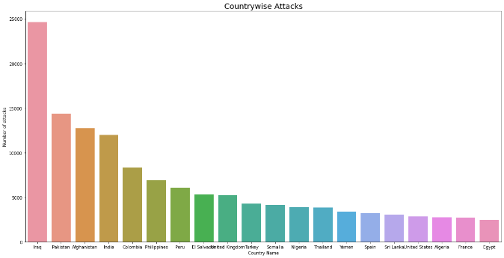6) Target Information:

* Target Type: 22 categories
* Several specific target/victim information, including names, nationalities, etc.

7) Perpetrator Information:

* Perpetrator Group Name: the name of the group that carried out the attack
* Several sub-group information, including number, claim, motive, etc.

8) Casualties and Consequences:

* Total Number of Fatalities, including Number of US Fatalities and Number of Perpetrator Fatalities

Model Planning

Our study focuses on two main goals, which are the prediction of success or fail attacks of worldwide terrorist groups, and the prediction of terrorist group based on the attack characteristics in a specific region, such as South Asia. Therefore, the model planning stage would be adjusted to each specific goal since the predictors and dependent variables are different.

Analysis

To begin with our data analysis journey, we will start with the time series statistical overview from 1970 to 2019, by customising the country

Data Summery

In this project, we tried to explore a dataset containing information about global terrorism acts since 1970, and attempted to make the findings as visual as possible. The dataset used is called the Global Terrorism Database, and contains over 100,000 terrorist incidents worldwide, with over 100 different attributes for each incident

* As the first step we started with Data Wrangling over the raw chunks of data, the process of which includes searching for and getting the sum of total null values present in the data set, renaming some of the columns and selecting only the columns which are necessary and filling suitable missing data.

With all of the time series information and geographical information, we knew that the best and most interesting way to understand this data would be by using visualizations

* Further in the next step, of number of killings by attacks analysis we plotted a bar-graph of the number of deaths each year caused by terrorist attacks. Here we could identify a stark rise in number of deaths in a particular year.

also we plotted a bar graph indicating the number of deaths caused vs the type of attacks. Through which we found out a stark difference in the methods of attacks and also the damage caused by different methods, which could also help us in identifying and preventing further attacks

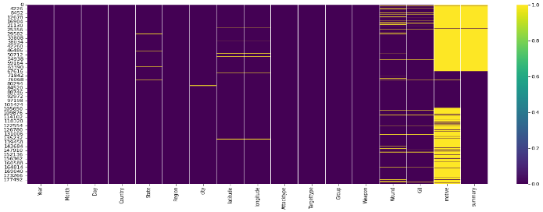

**8. Conclusion:**

Null column in our dataset are:1. latitude 2 longitude 3.wound 4.kill 5.motive 6.summery

Most null values are in motive and summery so we drop it. Latitude and longitude are no use of our analysis

* After the conclusion iraq is the first place in top of countries fallowed by pakistan, afghanistan, and india etc
* By observing that most attack were done central america and south asia.
* The year 2014 witnessed the highest number of terrorist attack and after 2004 the number of terrorist attack started increasing and in 1970 no of attack is very low
* Mostly bombing explosion attack type is used by the terrorist
* Taliban is the most dangerous terrorist group

**References-**

1. National Consortium for the Study of Terrorism and Responses to Terrorism (START). (2016). Global Terrorism Database. Retrieved from https://www.start.umd.edu/gtd
2. https://raw.githubusercontent.com/pranavpandya84/masters_thesis_on_global_terrorism/677eeb7594e3bc901e419d6fab050de8836eab21/thesis.pdf